* [Please join our BAND Page here](https://band.us/n/a5a0b8Jed6c5K)

MAIN IDEAS:

1. BLUEY & BINGO 3D PUZZLE
2. VR SIMULATION (ROBLOX?)
   1. Maybe not good because of seizures
   2. Also the controllers are too small
3. Keyboard with alphabet letters
4. Music Hoop Platform

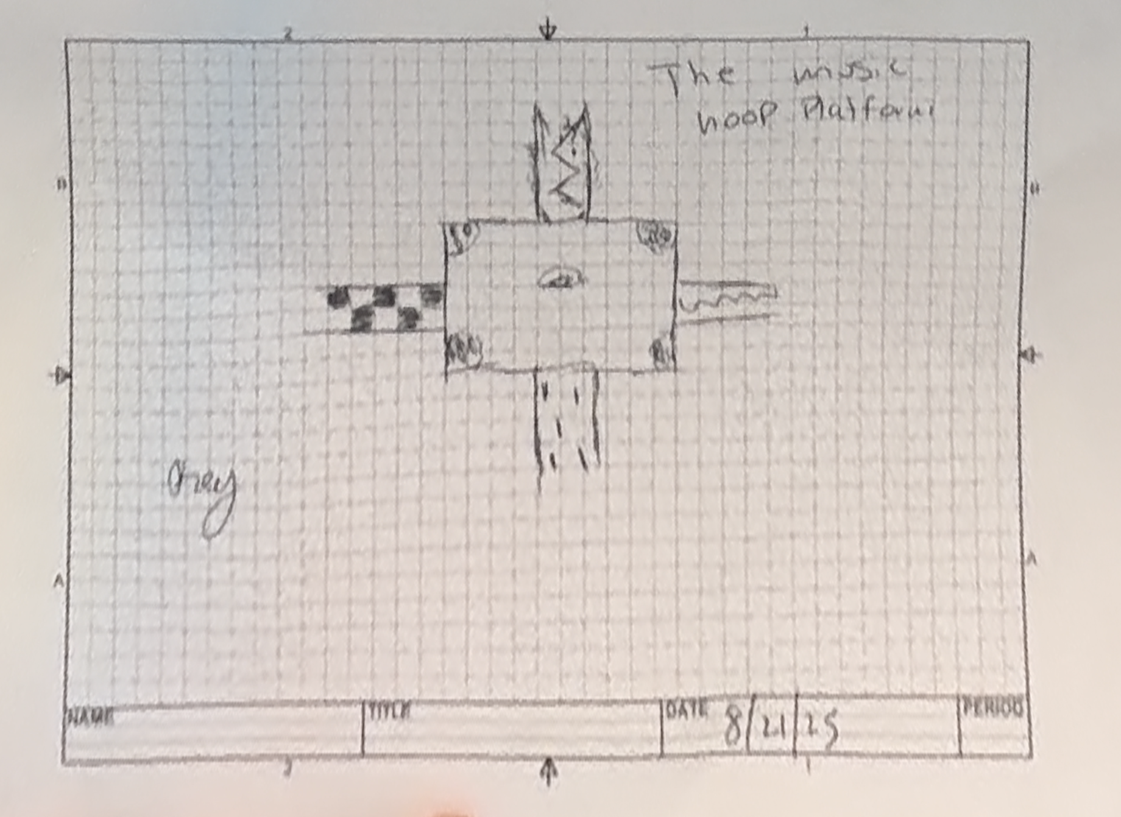

1. Team 1
   1. Nathan Bond
   2. Preston Cantlin
   3. Razo
2. Team 2
   1. Michael Syntax
   2. Benjamin Jung
   3. Jenna Campbell
3. Team 3
   1. Hezekiah
   2. Holden
   3. Noah